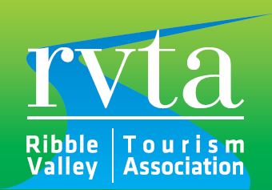

ANNUAL GENERAL MEETING 29th MARCH 2019 at 11a.m.

Holmes Mill

Minutes

- Welcome
Chair, Amanda Dowson welcomed everyone to the meeting and thanks James’s Places for hosting the meeting and Harrison and Drury for sponsoring the awards

- Apologies
Apologies from members are held on record

- The Minutes of 2018 meeting at Mytton were approved (prop Robert Parker sec Graham Geldeard)

- Matters Arising - there were no matters arising

- Chairman’s Report – A copy was circulated and approved. The Chair was thanked for her hard work. (prop Robert Parker sec Graham Geldeard)

- Financial report, circulated separately and approved (prop Joyce Holgate sec Simon Entwhistle )

- 2019/20 subscriptions – agreed at p.a. per business (Prop Ian Walmsley sec Marilyn Davies)

- Election of Executive Chair
- Amanda Dowson was elected Chair (prop Robert Parker sec Wendy Hope) Chairman

Election of Executive Committee
The following members were elected en-bloc onto the Executive Committee for two-years ((Prop Heidi Kettle sec Mark Sutcliff)
Robert Parker, Browsholme Hall
Becky Allen, Waddow Hall
Barbara Bryan, Mytton Fold Hotel
Owen Philips, Ribcage
Lee Bowden, Outdoor Elements
Claire Sutton Lancashire CC/ Clitheroe Castle museum)
Wendy Hope Stanley House Hotel
Heidi Kettle James’s Places
Hilary Roscoe Longridge H Centre

- The following are honorary members
Cllr Joyce Holgate RVBC
Tom Pridmore RVBC

- Any other business – There was no other business

- Questions – There were no questions
The meeting closed and The 2019 Ribble Valley Stars in Tourism Awards followed

