APPLICATION FOR MEMBERSHIP 2018

Company/business name……………………………………………………………………………………………………….
Type of business …………………………………………………………………………………………………………………….
Address ………………………………………………………………………………………………………………………………….
…………………………………………………………………………………………………………………………………
………………………………………………………………………………………………………………………………….
…………………………………………………….. Postcode ………………………………………………………….
Main contact(s): Forenames………………………………
Surname…………………….…………..
Position………………………………….. (i.e. owner, MD etc)
Principle contact Email……………………………………………………………………………………..…………………..
Trading Name of Organisation…………………………………………….(if applicable)
Legal/company name of Organisation…………………………………(if applicable)
Website Address…………………………………………………………………………………………………………………….
Facebook, Twitter or other social media sites ………………………………………………………………………..
……………………………………………………………………………………………………………………………………………….
Membership fees are £30 per year per business.
Invoice can be provided for you to pay direct into our bank account
BAC’s details: Sort Code 050378 A/C Number 39139859
Cheques should be made payable to "Ribble Valley Tourism Association" and returned to:
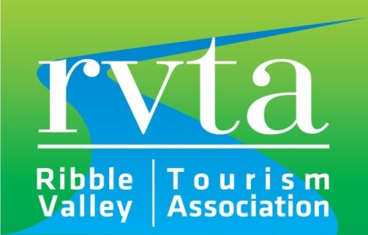
RVTA c/o Tom Pridmore
Tourism & Events Officer
Ribble Valley Borough Council
Church Walk
Clitheroe, BB7 2RA

