The Winners 2016
“Excellence is not a skill. It is an attitude.”
Ralph Martson

Our presenter

John Gillmore “Gilly”

Gilly always wanted to work in radio since the age of 11, after hearing his local radio station, BBC Radio Merseyside. Of course, when he was at school there was no such thing as media courses, so his teachers told him to get a 'proper job'.
This he did and went to work at his local Co-op in St. Helens as a counter clerk on the bank counter. He also got the chance to do the in-store announcements on the tannoy and compere fashion shows and exhibitions for them. He also volunteered with his local hospital radio station at Whiston.
He was persistent in sending off demo tapes to radio stations in the North West, eventually getting the chance to present for Red Rose Radio in Preston where he stayed for almost 13 years, and presented every programme.
Gilly left in 1998 to join The Bay in Lancaster and he joined BBC Radio Lancashire in 2005.
In 2015 Gilly was made ‘Tourism Superstar for Lancashire’ an award he greatly cherishes, and which demonstrates his enthusiasm for tourism and his love for the County of Lancashire
Gilly

The Winners 2016

Individual excellence in customer care

Lucy Allen

The first winner of Individual Excellence in Customer Care Award has a fantastic eye for detail, a critical skill in the business of making dreams come true, when you are dealing with Brides and Grooms. Her love for where she works, Eaves Hall, is always evident and she has a fantastic rapport with all staff, whatever their role, and she is always the first to encourage younger staff. The first award for Individual Excellence in Customer Care goes to Lucy Allen of Eaves Hall
Lucy Allen

Individual excellence in customer care

Clare Tauber

For any tourism business to survive and thrive, customer care has to be at the core of its values. And the next award winner not only has customer care at the heart of her own values, but she instils the very highest standards within her team, who work at the frontline of one of Ribble Valley`s busiest and most successful hotels. The next award for Individual Excellence in Customer Care is made to Clare Tauber the Reception Manager at Stanley House Hotel.
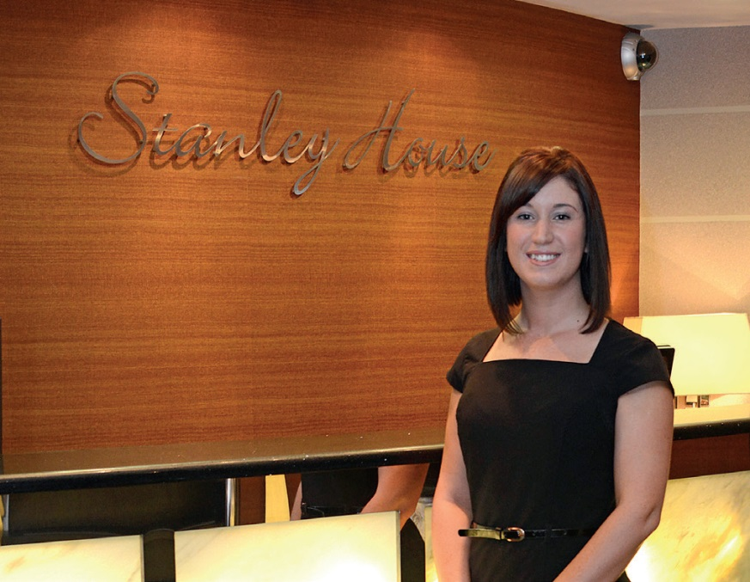
Clare Tauber

Individual excellence in customer care

Jen Wilkinson

Our third award winner also works in that hugely demanding and competitive world of weddings, a sector that is rapidly growing in Ribble Valley. This award winner works tirelessly to generate new wedding enquiries, and more importantly, provides outstanding service to Brides and Grooms. She is well known for her enthusiasm and positivity, attributes acknowledged most recently by a highly prominent wedding journalist. The third award for Individual Excellence in Customer Care Award goes to Jen Wilkinson of James’s Places.
Jen Wilkinson

team excellence in customer care

Gibbon Bridge Hotel

Quite often customer service is wholly embedded within an organisation from the top to the bottom, normally driven by the owner. And that is very much the case with the next award winner where the owner leads by the highest standards and expects it from everyone in the organisation. The standard of customer service provided by the next award winner is not only high, but naturally friendly and born out of a pride by every member of staff. This hotel has a very long and very well established reputation for the ways it welcomes and treats its customers, and it does so as a team, without exception. An award for Team Excellence in Customer Care goes to Gibbon Bridge Hotel.

team excellence in customer care

Fuss Pots and Flowers

Teams and businesses working in the tourism industry can vary considerably in size but each has an important role in making visitors welcome. The next award winner may not employ hundreds of staff but it is nonetheless well known for its cheerful friendly staff. It is also known for quality and value for money which are also so important in satisfying and moreover exceeding the expectations of visitors. This shop, in the heart of Whalley, plays an active role in community life and events and is a credit to the area. An award for Team Excellence in Customer Care goes to Fuss Pots and Flowers.

tourism in the community

Ribcaged Productions Ltd.

Arts and entertainments are another area of growth for Ribble Valley tourism and these are the areas where the local community and visitors can interact. We are blessed with some great venues, performers and production companies. The next award winner is an organisation which is passionate about the arts, and their mission is to create new, exciting, powerful and dynamic theatre that delights audiences. And not only do they do that but they also run Youth Theatre and Young Professional Actor classes as well as work in partnership with local Schools. This organisation is a great example of Tourism in The Community and it is awarded to Ribcaged Productions.

Team of the year

Chipping Steam Fair

Teamwork, so important to a successful business, and often critical to managing some of the major events in Ribble Valley. Most of the successful events in this area are run by volunteers and this presents added challenges. The winner of the next award, continually demonstrates, year on year, just what a successful team can deliver, a fantastic, popular event, entertaining thousands of visitors and preserving unique aspects of country life and local tradition. The Team of the Year award goes to the Chipping Steam Fair Committee.
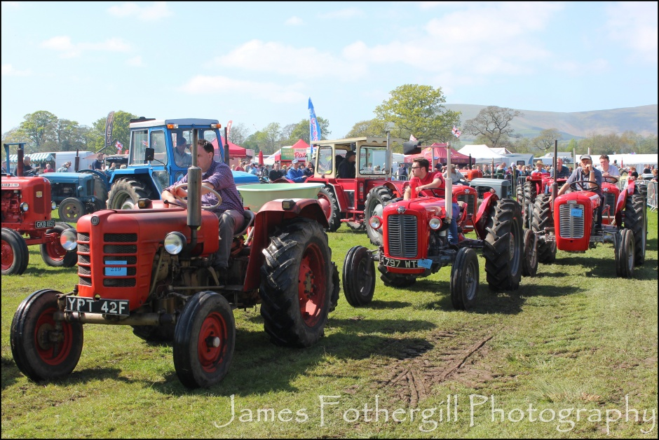
Chipping Steam Fair

Creativity in food and hospitality

Parkers Arms

The environment in which visitors dine is particularly important in the Ribble Valley where so many acclaimed food businesses flourish. The next award winner thrives with a passion for local food, and the more naturally produced or harvested the better. The team creates a most tasteful and vibrant atmosphere offering the highest possible quality of food in a beautiful rural setting. This village Inn has become a national haven for food fanatics and an award for Creativity in Food and Hospitality goes to the Parkers Arms, Newton in Bowland.
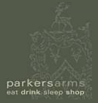
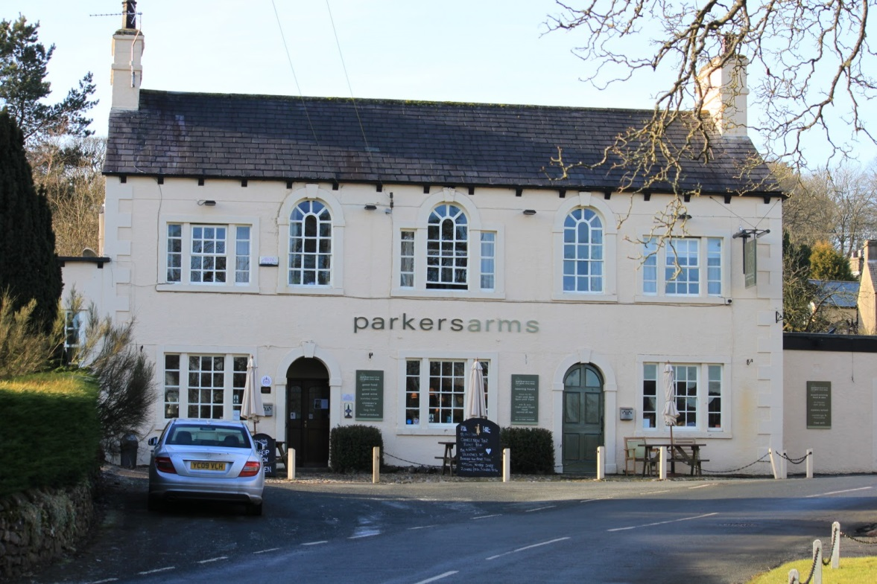

Creativity in food and hospitality

The Garden Kitchen at Holden Clough

The next award winner has managed to develop a rather unique dining experience which attracts visitors from across the region, to what really is a very remote location. Changing with the seasons and recognising every special occasion in the calendar, this rural business delivers a variety of delicious options. An award for Creativity in Food and Hospitality goes to the Garden Kitchen at Holden Clough.
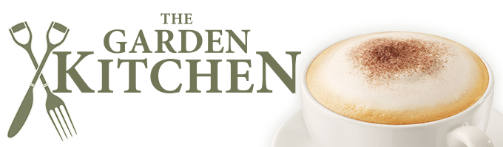
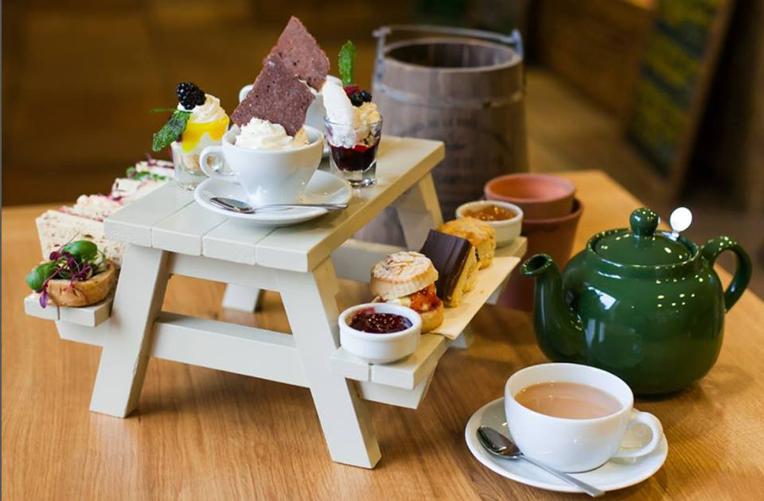

unsung heroes

Karen Eteson and the Housekeeping Teams

Many of the true stars in tourism are staff working behind the scenes busily doing roles which are absolutely essential to the delivery of quality tourism. The next award is for such an unsung hero who, in her day to day role, leads a team of a further twenty unsung heroes of local tourism businesses. Servicing the bedrooms at four busy hotels is no mean feat, especially when most of the overnight stays are single nights relating to weddings and corporate customers. With 72 bedrooms on four sites to clean and change to the highest standard between10.30am and 3pm is like a military operation. This year’s award for Unsung Heroes goes to Karen Eteson and the Housekeeping Teams of James Places
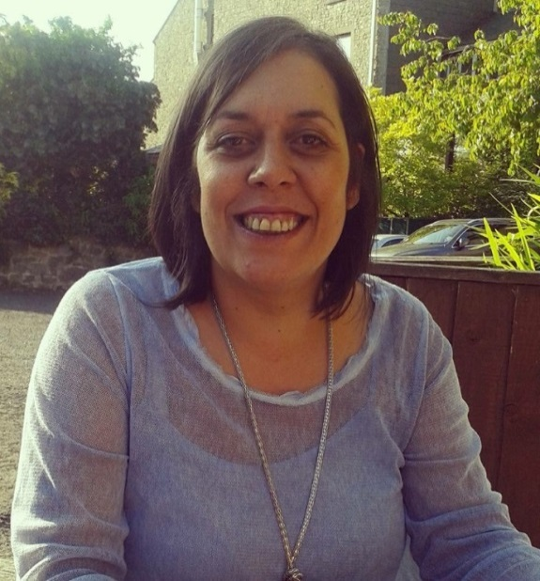
Karen Eteson

quality Tourism

Dale Hey Touring Park

Many visitors come to Ribble Valley to enjoy the outdoor life and we are fortunate to be able to offer great facilities both indoor and out. Visitors coming with a touring caravan are growing and they have great selection of parks to choose from. The next award winner offers high quality, five star facilities in very beautiful surroundings. The owners are both dedicated and committed, and an award for Quality Tourism goes to Dale Hey Touring Park
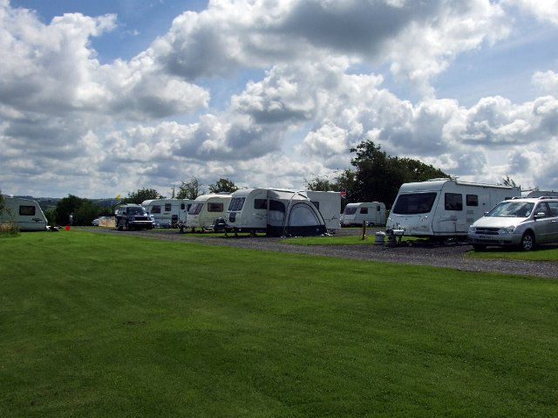
Dale Hey Touring Park

quality Tourism

The Assheton Arms

Quality is what Ribble Valley has in abundance, but to achieve it requires constant investment, rebranding and new ideas. One such business has continued to stay ahead of the game over the past year, by investing significantly in stylish new bedrooms. This high quality development has resulted in the creation of a most luxurious accommodation experience, and an excellent complement to its existing business. The award for Quality Tourism goes to the Assheton Arms Downham.
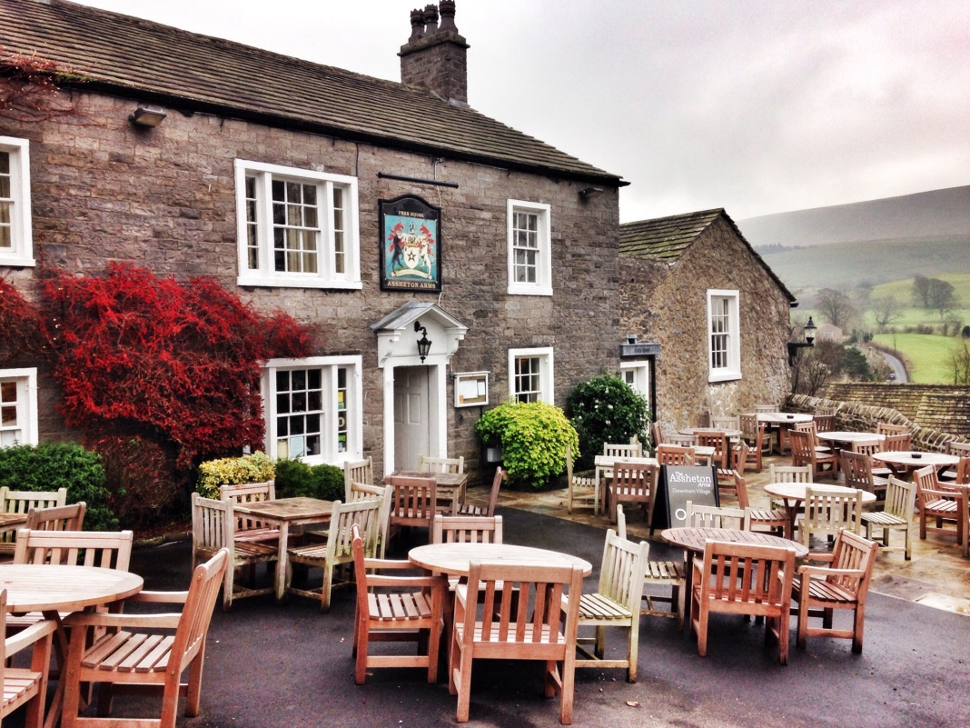
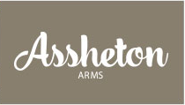

New event of the year

Ribble Valley Cycling Festival

Events are great for business, and it is always good to hear of a new event in the calendar, because for tourism it can mean first time visitors discovering this amazing area. This two week event was launched in 2015 and was an immediate success. There was a fantastic programme which included a pedal-powered music festival at the band stand, the Ribble Valley Ride sportif, a pop-up velodrome and other family-orientated cycling events. The best news is that is back for 2016. The New Event of the Year award goes to Ribble Valley Cycling Festival.
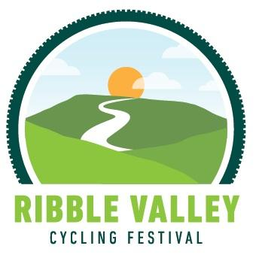

Creative tourism

Art Décor Gallery

In addition to the fantastic range of attractions and accommodation normally associated with tourism, there are also in this area, a good number of very high quality niche businesses which attract visitors for their particular offer. One such business close to Whalley has established itself as a world class facility and visitors come from across the globe to view the original art works on exhibition. This gallery has helped promote the work of many well-known, and up and coming artists and its gallery events and exhibitions are presented to the highest quality. The award for Creative Tourism goes to Art Décor Gallery.
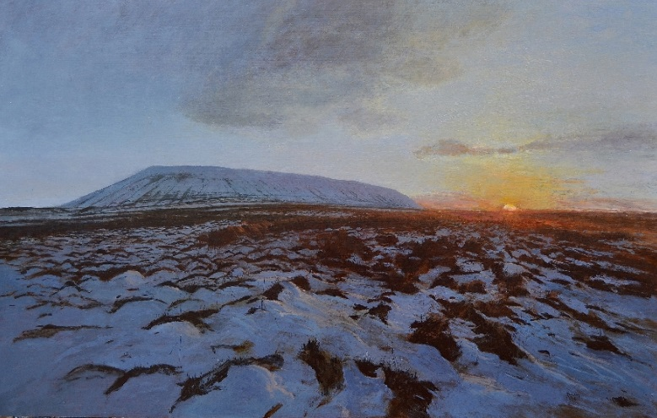

excellent website

Northcote

A good interactive website is an essential part of a business and critical for marketing new opportunities. There are many outstanding business websites. The winner of the most customer-friendly website provides attractive clarity on a website that is easy to understand and navigate, and maximises the beautiful imagery available within the business. The site is user-friendly, its language and graphics are clear, and it is informative and easy to use on different devices. Sharp, up-to-date and informative, the Excellent Website award goes to Northcote.
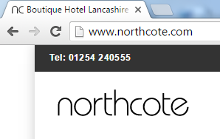

social media star

Melt

Everyone is talking about Social Media of various kinds and the most successful businesses are using it effectively. There are many examples of the way that Facebook and Twitter are used to promote local tourism businesses but one stood out this year. Kept fresh and informative, and using fantastic photography, a visit to their Facebook page certainly makes you want to visit this place. The Social Media Star award goes to ‘Melt’.
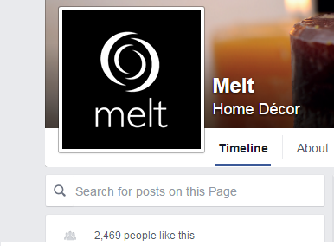

event of the year

Tour of Britain

Events are becoming a major reason to visit the Ribble Valley and it is always good to recognise their importance in these awards. In considering what might have been the event of the year for 2015 there was one which stood out above all others, an event which attracted visitors in their hoards but which was also embraced by local communities. It was an event which required public, private, and voluntary sectors working together to prove it could successfully be hosted, and it was in magnificent style and the sun even came out in celebration.
The winner of the Best Event of the Year award goes to the Ribble Valley Borough Council as lead organisation for successfully hosting the Tour of Britain, in Ribble Valley.
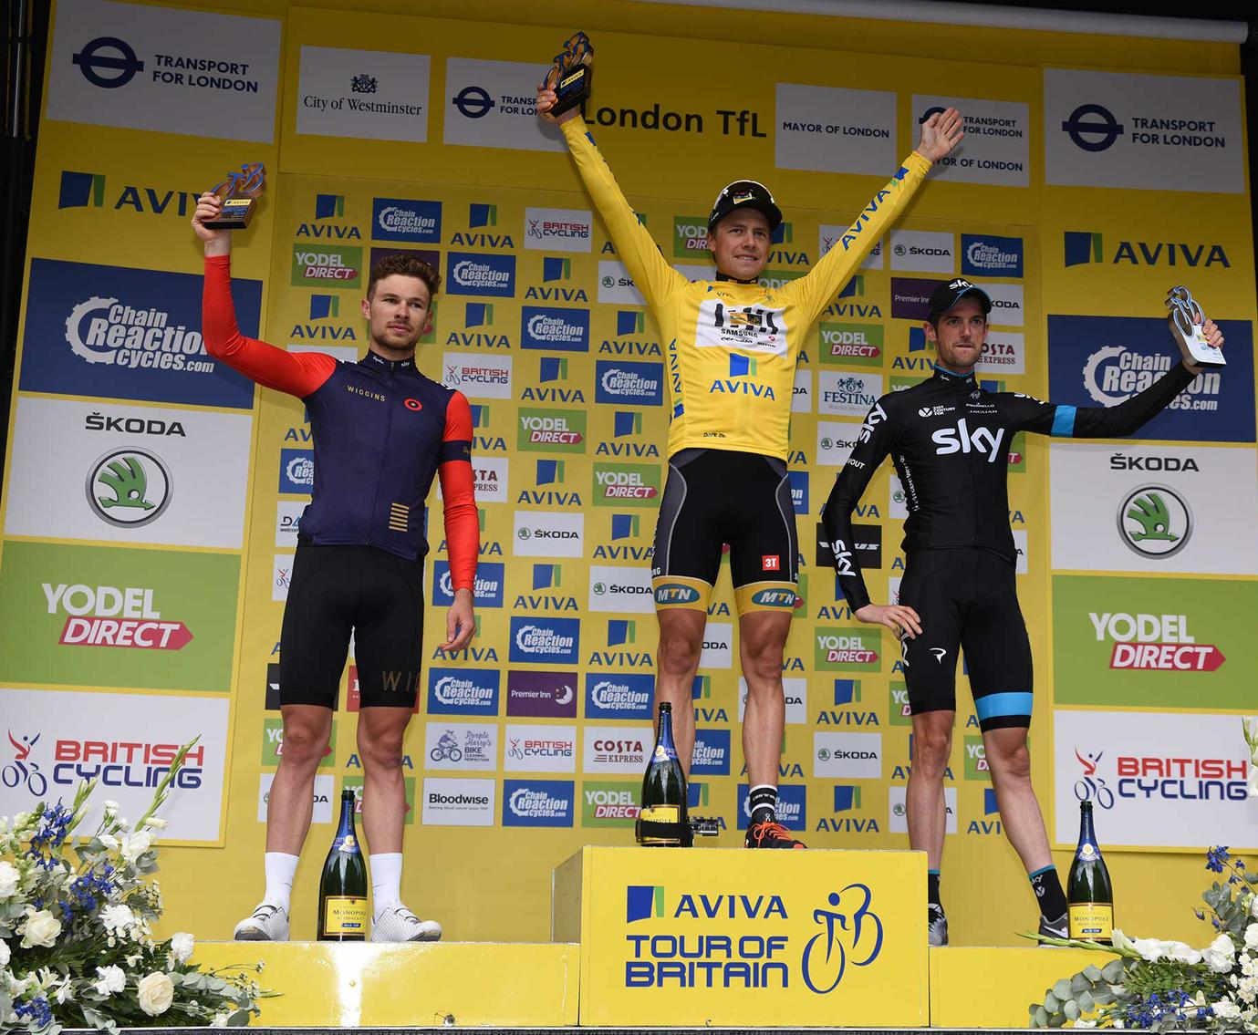

New business of the year

Crimpton Farm Holiday Cottages

Each year sees new tourism businesses opening in this area and some stand out for quality. One welcome edition has provided much needed self-catering accommodation into the rural area, which is valuable for holiday visitors but also short stay visitors, particularly wedding guests, who come once and then return. The accommodation is finished to the highest standards and visitors mention in their nominations for this business, the best sleep they’ve ever had and the warm and friendly welcome provided by the owners. The award for New Business of the Year goes to Crimpton Cottages.
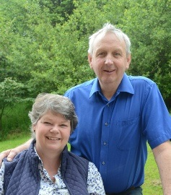
Crimpton Farm
Holiday Cottages

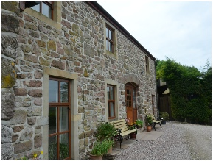

transformational tourism

The Red Pump

In Ribble Valley we are lucky to have many forward thinking businesses, constantly investing in their properties and developing new ideas. The award of Transformational Tourism recognises where a failed or struggling business has been revitalised into successful business enterprise. One such business has resulted in the development of a truly stylish pub and restaurant being created with new beautifully appointed en-suite bedrooms . The winner has found a niche in its food offer by specialising in the highest quality steaks. And as we speak, there is further transformation taking place outside, with the development of yurts. The winner of the Transformational Tourism award is the Red Pump at Bashall.
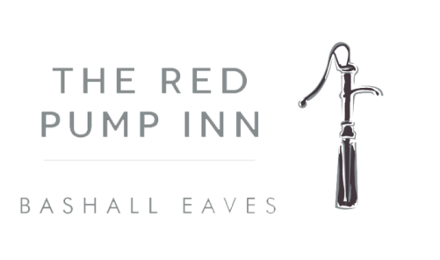
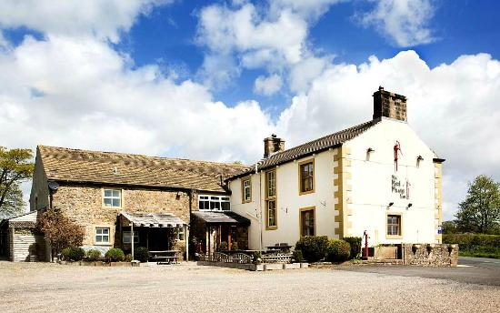

Innovation in food and hospitality

Seafood Company

Ribble Valley is blessed with many amazing places to eat, so much so that it is a highly competitive market. This means that businesses need to be creative and innovative in their menus, their service and their marketing. One company has shone out over the past year for the way it has used marketing and events to develop the business at their outlets, two of which are in Ribble Valley. Themed food nights, special events and tasting sessions have been popular attractions, and the way in which the company manages its marketing and social media is fresh and exciting. Just last week within hours of the snow falling, special snow promotions were being emailed out to regular customers. This company is not only clever in its approach but fast too, responding swiftly to national events, calendar dates and even the weather in its marketing. An award for Innovation in Food and Hospitality goes to the Seafood Company.

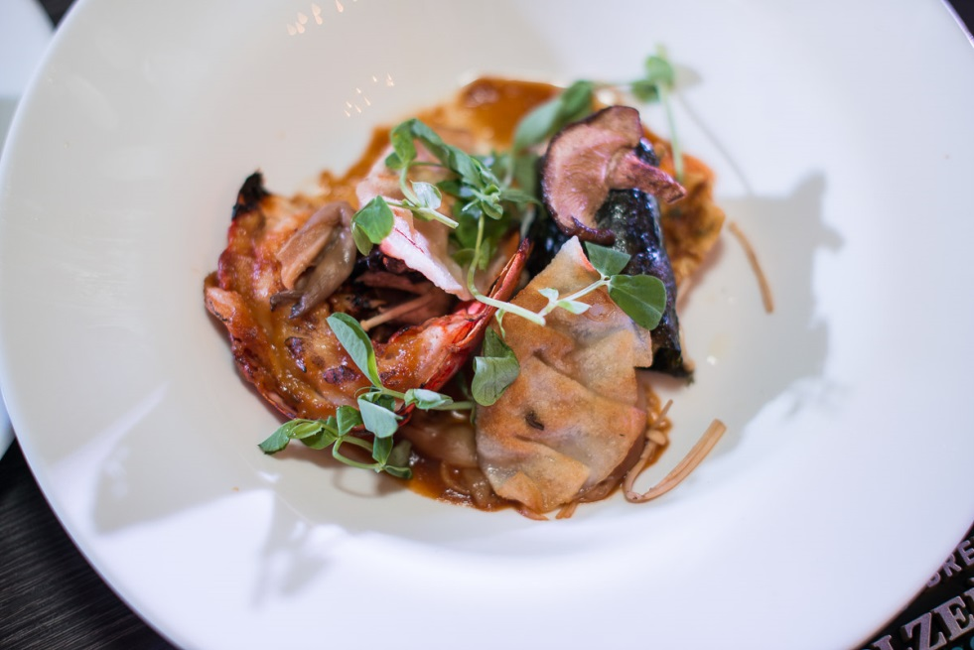

Tourism champion

Wendy Hope

In celebrating Tourism at these awards it is great to recognise the champions and there is one particular person whom the association wishes to recognise this year. She is someone who is passionate about providing excellent customer service and she instils this amongst her team in a very large, busy and diverse business, where she is responsible for marketing sales and events. Basically she drives and develops new business. She is held in very high regard by everyone in the Ribble Valley tourism industry and is a past committee member of the association. She also has an excellent reputation beyond, particularly across Lancashire. The one word you will hear time and time again about this very well respected person is professional, in everything she does. She is of course Wendy Hope of Stanley House
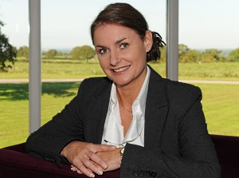
Wendy Hope

Tourism heroes

Whalley Lions

The next award is certainly unique. During the recent terrible weather, parts of Ribble Valley were badly affected, people made homeless and business severely disturbed. This clearly had a negative impact on trade and subsequently tourism. One local group shone out during these troubled times, a group determined to help local people and restore the social and economic life of the community which they value. Under inspirational leadership, Whalley Lions club were, and continue to be the driving force of the restoration of normality and for that work the Ribble Valley Tourism Association believe they should be recognised and thanked. The award of Tourism Heroes goes to Whalley Lions Club

honorary life member

Lilian Hargreaves

The association has the power to award Honorary Life Membership to people who have made a significant contribution to tourism in this locality over a number of years. One member who has made such a contribution, first started her business with her husband in 1982, when, following an outbreak of swine vesicular disease on their farm they decided to diversify into tourism by starting farmhouse bed and breakfast. They were indeed pioneers of their generation to diversify in this way as what started with two bedrooms became 4 with a thirty seater restaurant. This was followed swiftly with eight more bedrooms, then fifteen more, then a function room then a golf course replaced the farm, then fifteen more rooms to form what we now know as Mytton Fold Hotel and Golf course, a hugely successful family business. Whilst her husband Frank is no longer with us Lilian Hargreaves has maintained a firm control on the business and, to this day can often be found front of house offering a welcome smile to guests and visitors. The hotel complex that she and her husband created, with which her family of several generations are now actively involved, is the epitome of the Ribble Valley outstanding service, creativity, good hospitality and well maintained landscapes. The award of Honorary Life Member this year goes to Mrs Lilian Hargreaves.
Lilian Hargreaves
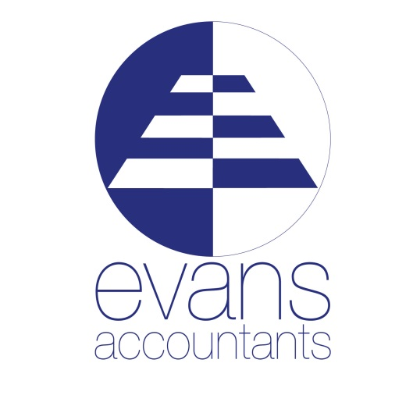

Proud Sponsors of the
`Ribble Valley Stars in Tourism Awards 2016`
Tourism and leisure represent a large and very important sector of our region`s business community. We understand running a business in this sector comes with unique pressure. Since we feel so passionate about this area and the businesses within, we have created accountancy and advice packages specifically tailored to support tourism and leisure.
Services for Tourism and Leisure Businesses:
- Annual and Management Accounts
- Corporation and Personal Tax Compliance
- VAT Advice
- Payroll and Management of Seasonal Workforce Changes
- Profit Forecasts and Cash-Flow Analysis
- Tax Planning Advice
- Statutory Audits
http://www.evansaccountants.com/ |01200 428460

